Hi Squids:
An update from the farm!
When we moved here in New Brunswick from Ontario nearly 3 years ago, we brought one dog, three cats and a half dozen chickens.
The dog died of old age as did one cat.
The chicken flock grew to about 30 but when the laying slowed Kenny culled the herd back to about seven.
Last fall we started accumulating beef cattle, first four, then two more in the spring and then this past Monday at 7:30 in the frosty morning the number became seven as in the pictures below.
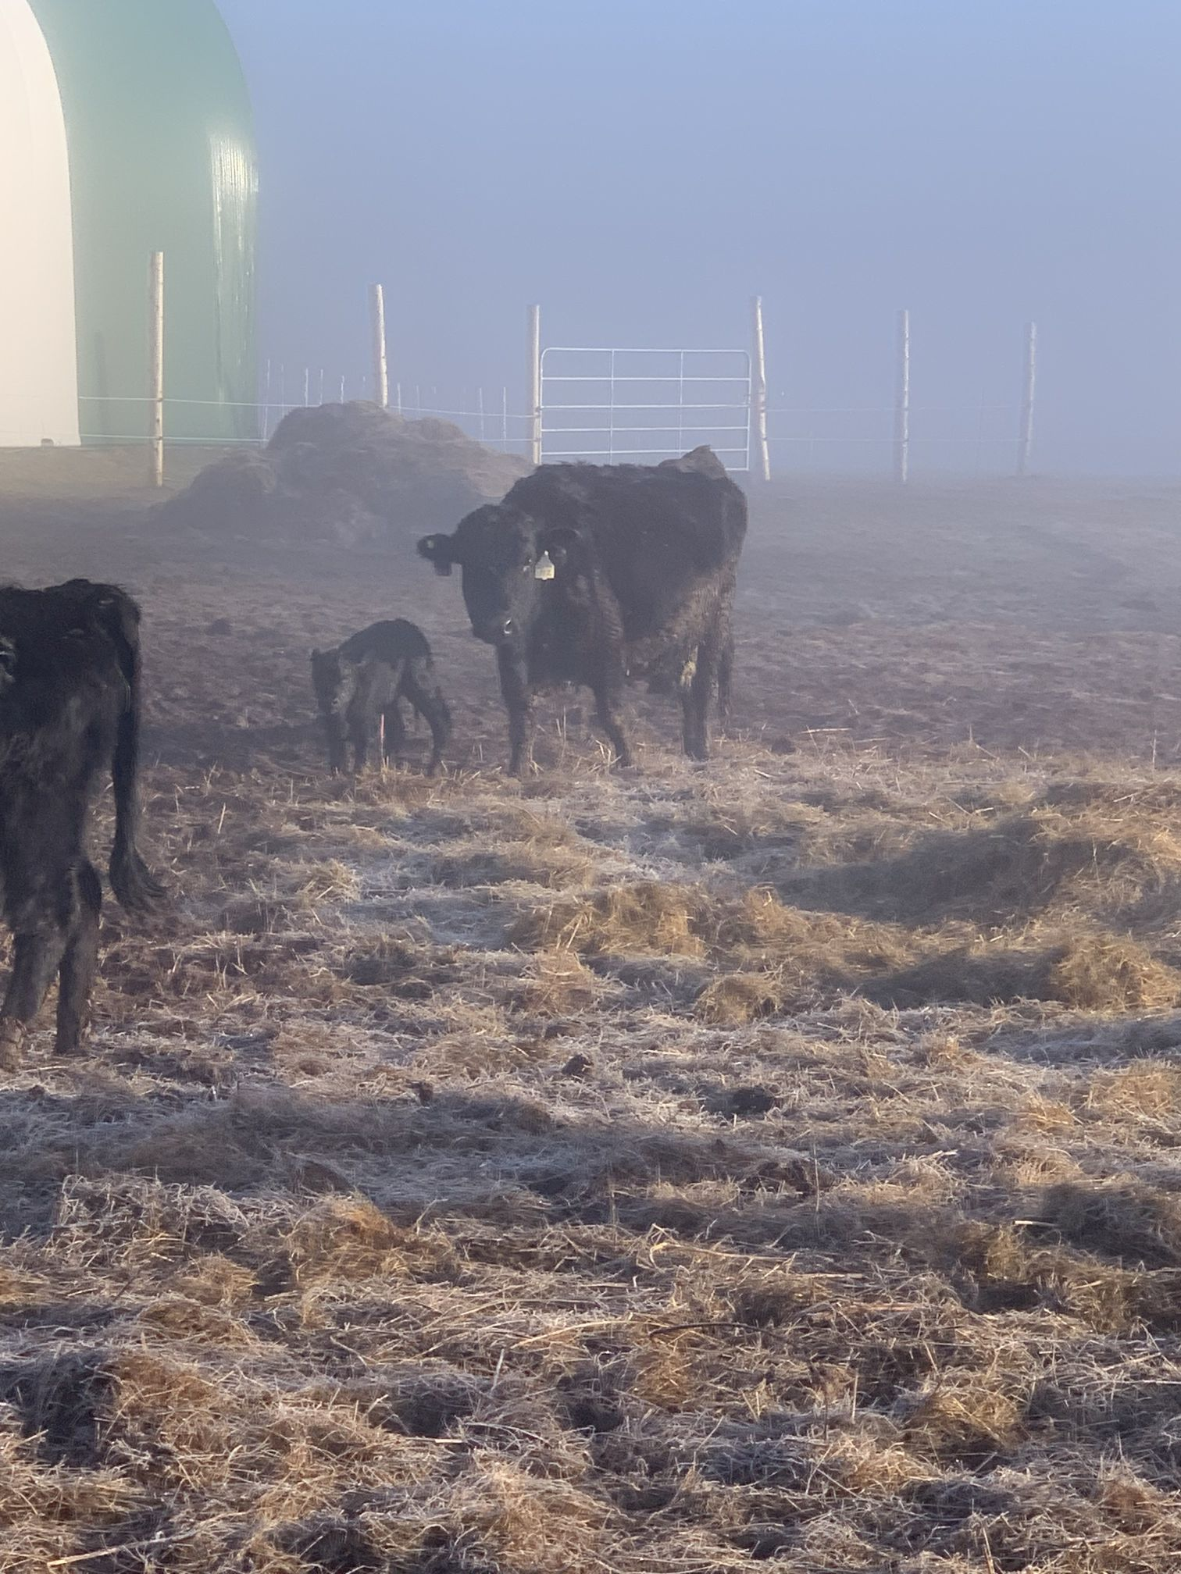
Then one hour later.
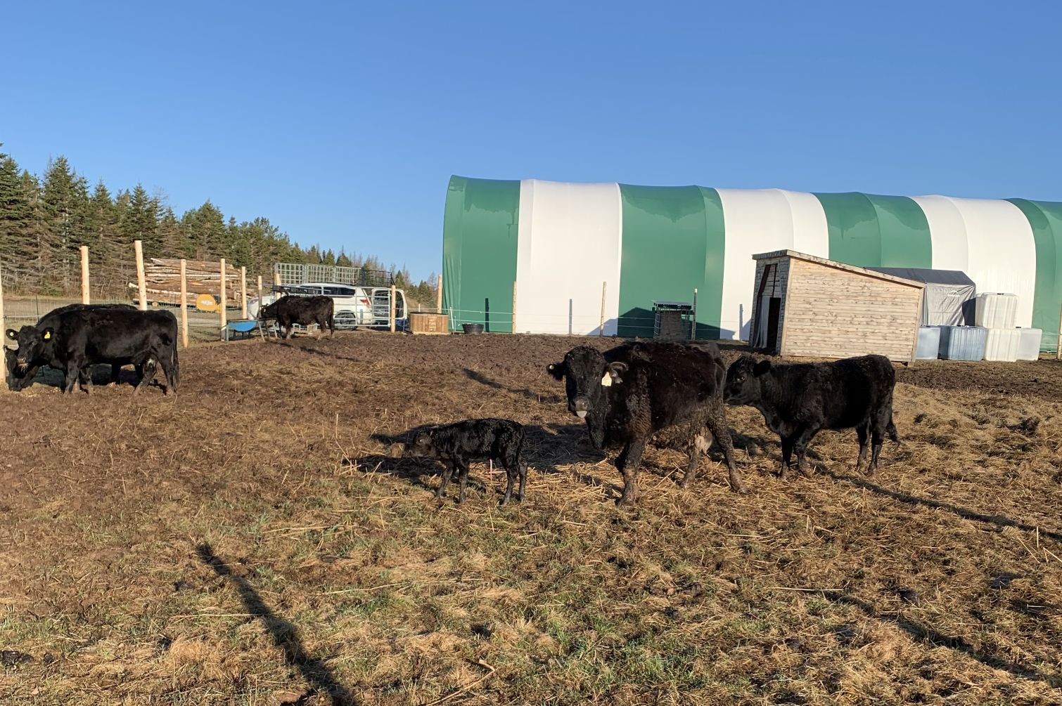

Uno, his name since he is the first-born on this property since we arrived, hadn’t figured out where he would get his breakfast, so, with the help of a neighbour, we got him started. Chicks didn’t get names.

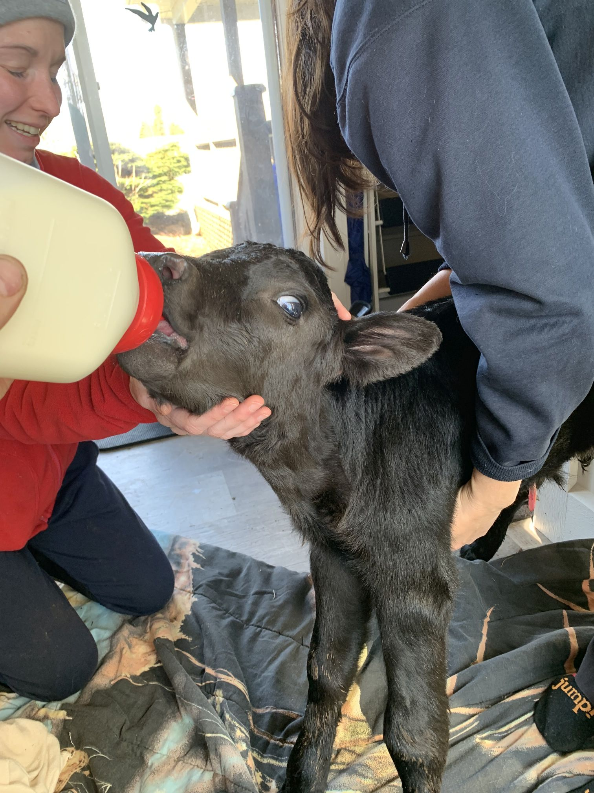

Dos (name of the next calf) is expected in a couple of weeks. Hopefully it will be a warmer welcome.

Till then, Wayne & Sylvia

