Hi Squids:
Well, the stork arrived sooner than expected. 7 new baby pigs arrived Monday, March 31, avoiding any reference to April Fool’s Day.
Everyone calls them piglets, but when I was a kid, they were called shoats. What’s in a name A pig by any other name would smell as sweet.
Here are some pictures:
Waiting for the last 2 shoats. 1.5 lbs on the way to 300 lbs.
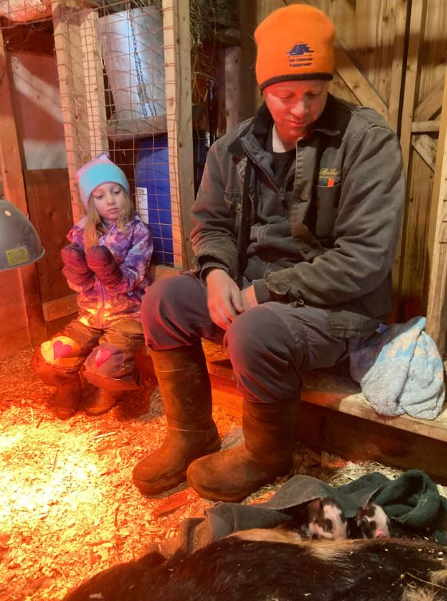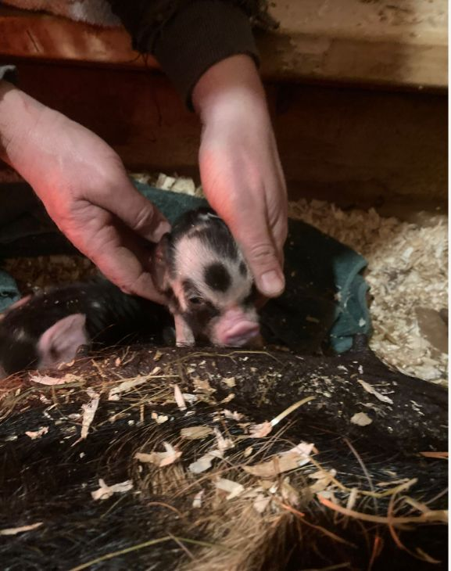

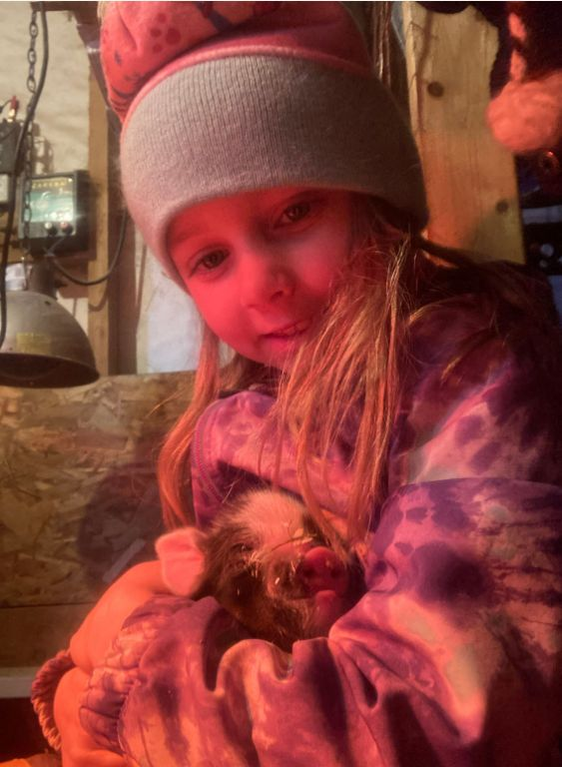
Here is Gabi, dreaming up names. 7 pigs?
Why not Sunday, Monday, Tuesday, etc?

The weather will probably be a major topic in this week’s Squamidian but we got nothing but a trace of snow and then a lot of rain. I’m anxious to hear what happened in Ontario to the Squid readers.

By the way, there were no fish in the sap pails after the river water receded because there were no pails. Simple explanation. In the short period between breakfast and dinner, when I saw the river had risen so much, Ken had gathered them up.

I will close with a running score of the population changes here on our New Brunswick Farm.

